

CourseWork2
Introduction To Programming

Haram Sabir
ID: 330017
ITP
sem1

Car Rental System

Introduction
The Car Rental System is a file-based application designed to manage car renting. It allows users to rent cars based on specific preferences, cancel rentals, and view available cars. This system uses a text file “car” to store the booking data.
Nouns and Verbs Analysis

Nouns:Entities and Objects:
- Car (main entity, class)
- CarNum (car identifier)
- CarType (type of car, e.g., sedan, SUV)
- RentalPrice (cost of renting a car)
- GPS (availability of GPS feature)
- Sunroof (availability of sunroof feature)
- Email (associated with the renter or "free" if available)
- System (Java system for input/output)
- Scanner (input-reading utility)
- File (represents the text file storing car data)
- Menu (user interface menu for choices)
- Choice (user selection in the menu)
- Array (storage of car objects)
- List (temporary storage for loading cars)
- FileScanner (scanner for reading file contents)
- Input (user-provided values)
- Output (system-provided messages)
- Match (best-matching car)
- PartialMatch (next-best matching car)
- Attributes (characteristics of a car, e.g., type, GPS)
- Line (data from the file)
- Buffer (temporary storage for input/output)
- Writer (used for saving car data)
- InvalidLine (data that doesn't fit the expected format)
- RetryAttempts (limit for user input validation)
- Errors (e.g., IOException, InputMismatchException)
- Path (file location)
- Rental (overall renting process)
- Validation (checking inputs like email)
- Response (user feedback for car match options)

Verbs:Methods/Actions:
- File Operations:
  - Load (e.g., loadCars for loading car data)
  - Store (e.g., storeCars for saving car data)
  - Write (writing to the file)
  - Read (reading file contents)
  - Open (e.g., opening a file or input stream)
  - Close (e.g., closing the scanner or file writer)
- User Interaction:
  - Display (showing menu options and data)
  - Enter (input values from the user)
  - Print (outputting information to the console)
  - Pick (select an option)
  - Prompt (ask user for input)
  - Validate (checking the correctness of input)
- Car Actions:
  - Rent (e.g., rentCar for renting a car)
  - Cancel (e.g., cancelRental for canceling a rental)
  - Check (e.g., isAvailable to check car availability)
  - Get (e.g., getCarType to retrieve car attributes)
  - Set (e.g., setEmail to update renter information)
- String Operations:
  - Convert (e.g., toLowerCase for case normalization)
  - Equals (e.g., equalsIgnoreCase for string comparison)
  - UseDelimiter (parsing lines with delimiters)
- Control Flow:
  - Break (exit a loop)
  - Continue (skip iteration)
  - Return (exit a method)
- Exception Handling:
  - Catch (handle errors, e.g., IOException)
  - Throw (propagate errors)
  - Skip (e.g., invalid lines in the file)
- Search and Match:
  - Search (e.g., finding the best match for car rental)
  - Compare (e.g., car attributes for matches)

- Error Handling:
  - Retry (allow multiple input attempts)
  - Handle (process exceptions)
  - Report (output errors)
Class Diagram:
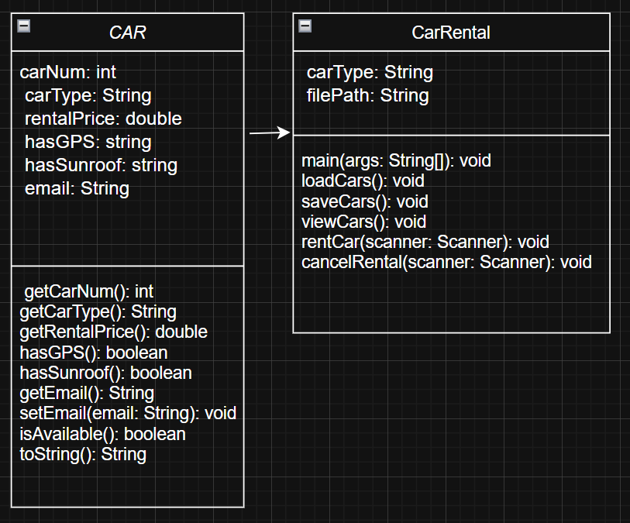
- CarRental Class:
  - Manages car rentals and interacts with users.
  - Attributes:
    - cars: Array of Car objects.
    - txtFile: File path for car data.
  - Methods:
    - main(): Main program logic (menu and user interaction).
    - loadCars(): Loads car data from the file.
    - storeCars(): Saves car data to the file.
    - rentCar(), cancelRental(), viewFile(): Handle car rentals, cancellations, and viewing all cars.
- Car Class:
  - Represents an individual car with rental details.
  - Attributes:
    - carNum: Unique car number.
    - carType, rentalPrice, hasGPS, hasSunroof, email: Car details and renter info.
  - Methods:
    - getCarNum(), getCarType(), etc.: Getters for car details.
    - setEmail(): Sets the renter’s email.
    - isAvailable(): Checks if the car is available for rent.
    - toString(): String representation of car details.

Relationship:

CarRental manages an array of Car objects, performing operations like renting, canceling, and viewing cars. Car stores the details of each individual car.

Conclusion
The Car Rental System is a straightforward and efficient tool for managing car rentals. It uses object oriented principles to organize car data and provides an easy-to-use interface for users.

